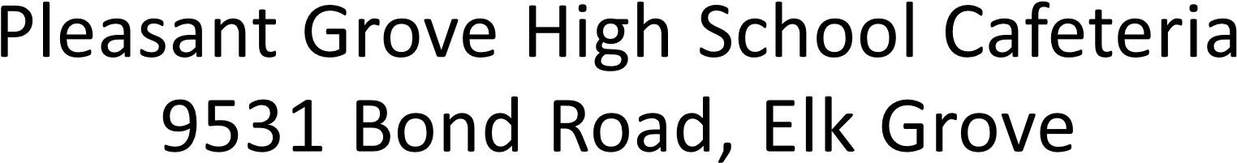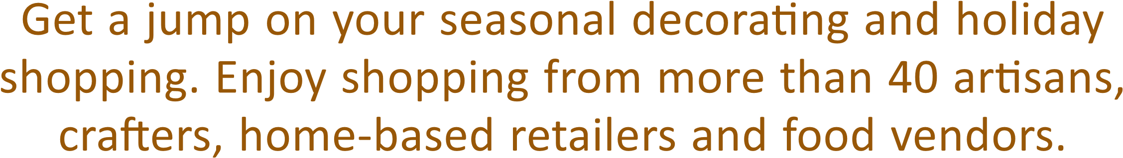

Saturday, November 12th, 2016

10:00 am - 4:00 pm