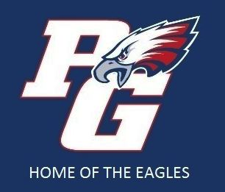 2016-2017 PGHS Band Spirit Wear Order Form Orders Due by: Wed., August 17

Student Name: ___________________ Phone Number: __________________ Email: _______________
Please make check payable to PGHS Band Boosters. Staple check or an envelope with cash to this order form and return to Mr. Souliere. If you’re paying with cash, please write your name on the envelope. Any questions, please contact Terry Kammerer at 916 686-6593 or treadkammerer@hotmail.com
Item: Size(s) Color Quantity Unit Cost Total Cost
Band T-Shirt: Blue with Band logo on the front.
Adult Mens S,M,L,XL and XXL. 100% cotton __________ _____NA_____ ___________ X $15 = ___________
($3 for each sold to Student’s Account)

Band T-Shirt: Blue with Band logo on the front
Adult Womens S, M, L, XL and XXL 100% cotton __________ _____NA_____ ___________ X $15 = ____________
($3 for each sold to Student’s Account)

Band Long Sleeve T-Shirt: Blue with Band logo
on the front. Available in Adult S, M, __________ _____NA_____ ___________ X $17 = ___________
L, XL and XXL. !00% cotton ($3 for each
sold to Student’s Account)

Hooded Sweatshirt: Red or Navy with
Band logo on the front. Printed on heavy
duty 50/50 cotton/poly blend. Available __________ __________ ___________ X $27 = ___________
in Adult S, M, L, XL and XXL. ($3 for
each sold to Student’s Account)

Crew Neck Sweatshirt: Red or Navy
with Band logo on the front. Printed on
50/50 cotton/poly blend. Available in __________ __________ ___________ X $25 = ___________
Adult S,M,L,XL and XXL. ($3 for each
sold to Student’s Account)

Zipper Hooded Sweatshirt: Red or Navy
with Band logo on the left side. Printed on a
50/50 cotton/poly blend. Available in Adult S, __________ __________ ___________ X $32 = ___________
M, L, XL and XXL. ($3 for each sold to Student’s
Account)

Decal: Die cut vinyl window decal with white __________ _____NA_____ ___________ X $5 = ___________
PG eagle logo. Size in 3.75” by 5”
CHECK # _____________ TOTAL COST: ______________

