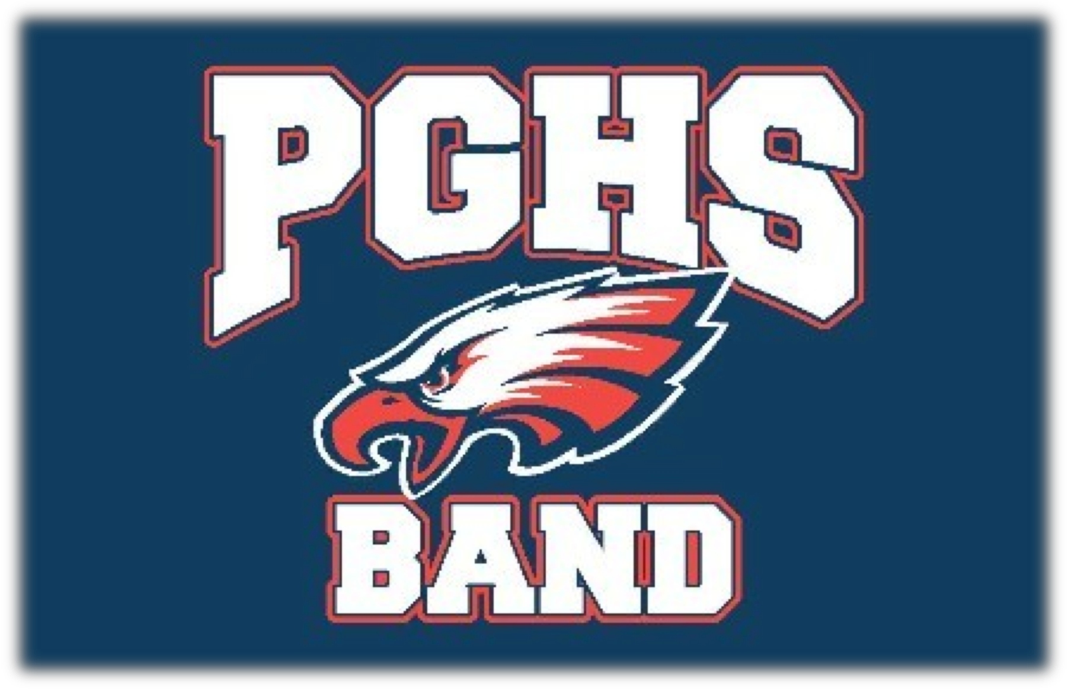

PGHS & KAMS
BAND HANDBOOK
2016-2017

Table of Contents

i Welcome

ii A Note to Parents

1 Forward

2 Course Descriptions

3 Grades

4 Semester Grading

5 Attitude

6 Uniform Guidelines

7 Festivals and Contests

8 Class/ Rules

9 Football Games/Bus Rules

11 Assertive Discipline

To All Band Students...

Welcome To Pleasant Grove High School...

To those of you who are new to our high school band program, you have the opportunity to meet new friends, establish a tradition of excellence for years to come, and participate in one of the most active and exciting activities at Pleasant Grove High School. You need to realize, as we do, that you are the future of this band program. I encourage that you and your family become actively involved. It is important to note that one side benefit of the total band experience is the fun memories and lasting relationships that are developed by both students and parents.

The 2016-2017 school year will mark the 11-year anniversary of our school/program, and it gives us all the opportunity to carry on the outstanding tradition of excellence that has been established in such a short amount of time. I encourage all students to step up and become leaders. The band will only be as strong as its weakest member, so we all must make a collective effort and strive for the group to be successful as a whole.

To our sophomore, junior, and senior class members: you know what it takes to achieve success as a member of our high school music program. We expect you to continue your high achievement and improvement through pride and commitment to Pleasant Grove High School.

This handbook is to be used by students, parents, administrators, staff, and director as a convenient source of information regarding the varied aspects of the PGHS Band. Students and parents should read this handbook carefully and must sign the syllabus/agreement form upon becoming a member of the Pleasant Grove High School Band. Members will be expected to understand and abide by all rules and regulations set forth in this book.

Welcome! Mike Souliere
Band Director

i

A NOTE TO PARENTS...

Parents play an important part in the Pleasant Grove High School and Albiani Middle School Music Program. Without the assistance and teamwork of band parents it would be difficult to obtain the level of success we want the music program to reach. There are many options a parent can choose in supporting their child’s music education:

1. Become a Band Booster or Volunteer for parent committees. There are many different projects with which we need your assistance, and everyone can find a task that suits them best: chaperone, uniforms, transportation, equipment handling, piano accompaniment, sewing, meals, and publicity are just a few of the areas we need support in.

2. Attend Band Booster Meetings. There are 5 general booster meetings scheduled throughout the school year. The meetings will begin at 7:00 p.m. in the PGHS Band Room. We try to keep the meetings to one hour. The date of the meetings will be specified on the band calendar.

3. Be supportive of the Music Program and your child's participation by:

- Assisting your child to be prepared and punctual for every rehearsal and performance.

- Notifying the director if your child is to be absent or late for a performance or rehearsal. Absences from performances are excused only in the event of extreme emergency, serious illness or hospitalization of the student, death in the family, religious holiday, or other reasons deemed excusable by the director. Work is not an excuse for missing a scheduled event. The music director must approve all absences from performances or rehearsals.

- Encouraging your child to practice at home and help them find a quiet place to do so.

- Showing your interest and support in your child's music study by attending every performance possible.

- Discussing with directors and staff anything that will help them understand and better serve your child.

- Arranging for private lessons for your child, if at all possible.

Course Descriptions

KAMS Beginning Band- This is a performance ensemble that introduces students to reading music and participating in a band class. Students learn the basics of music through performance on a band instrument. Students learn basic musical elements, individual and group performance skills, music theory, critical listening skills and musical analysis. There is no prerequisite for this course.

KAMS Concert Band- This is a performance ensemble where students learn intermediate musical elements through performance on a band instrument. Students learn basic individual and group performance skills, music theory and history as well as critical listening and music analysis skills. Students enrolled in this course have the unique opportunity to play and perform with the Pleasant Grove High School Marching Band and Jazz Band.
Prerequisite: At least one year of band experience on same instrument.

PGHS Concert Band- This is a performance ensemble that provides fundamental instruction, theory, and practice in wind and percussion instruments. Instruction and performance during the first 9 to 10 weeks of the school year focuses on Marching Band; during the rest of the year the focus will be on concert literature. Students enrolled in this course will perform at a variety of concerts and school programs including our annual seasonal concerts, festivals, parades, and athletic events. The students are taught the principles of individual and group achievement through practice and performance with their instrument. Musicianship, group unity and performance are the primary goals of this course. This class may be repeated for credit. Prerequisite: At least one year of band experience on same instrument.

PGHS Marching Band- This is a performance ensemble that provides fundamental instruction on marching techniques and practice in wind and percussion marching instruments. Instruction during the first 9 to 10 weeks of the school year focuses on Marching Band. Concert Band members make up the Marching Band. The most active of bands, it requires extra rehearsals, summer rehearsals, and some weekend time throughout the school year. The marching band performs at athletic events, parades, and band reviews. This class may be repeated for credit. Prerequisite: At least one year of band experience on same instrument

KAMS/PGHS Jazz Bands- This is a performance ensemble that is enrolled by audition only. This class is designed for the more advanced students enrolled in Marching/Concert Band, and provides fundamental instruction through big band rehearsals, small group instruction and performances. Students in Jazz Band focus on jazz techniques, style, and improvisation. Students enrolled in this course perform at our annual seasonal concerts, academic awards, jazz festivals, and other school programs. This class may be repeated for credit. Prerequisite: At least one year of band experience on same instrument and must be enrolled in concert band.

GRADES

Music classes are unique courses at Pleasant Grove High School and Katherine Albiani Middle
School. They have curriculum requirements just as any other academic discipline, but also have “out of class” time requirements. The strength of the band program is the consolidation of these requirements into one, performance based, academic course of study. The level of commitment from each individual student is the driving force behind the organization and is reflected in the level of achievement reached by the individual and the program.

Band is a learning activity. Rehearsals, whether during or after school, are the means by which students learn, and by their very nature cannot be reproduced or made up. Therefore it is imperative that students be present unless the absence is absolutely unavoidable. Excessive absences will undoubtedly affect a student’s performance and grade. Rehearsals and performances are not optional, and are reflected in the student's grade. Performances are viewed as major
tests: a performance is a learning experience that cannot be duplicated via rehearsal hall or practice- room; the level of concentration required in a public performance assists each student in developing an insight into his/her own level of performance; a performance is an important evaluative tool, allowing comparison of a student's performance in relation to classroom objectives presented and with past performances. Absences from performances are only excused in the event of extreme emergency or various other reasons deemed excusable by the director. The music director must approve all absences from performances or rehearsals IN ADVANCE. You can contact Mr. Souliere via schoolloop or call the school at 686-0230 ext. 4776, and leave a message.

Finally, the Band as an organization provides a medium through which student's progress academically, musically, and socially. Musicianship, attitude, attendance, punctuality, conduct, and a desire for excellence are absolutely expected from each member of the Pleasant Grove High School Band. Individual practice and preparation are essential. No other discipline in education requires the high level of achievement from all participants, as does musical performance. Through the level of commitment required we hope to better prepare our students for the responsibilities encountered throughout their lives. A student's grade in Marching/Concert Band and Jazz Band are based on the following percentages:

Grading Procedure
10% Attitude
10% Class Attendance
20% Class Participation
60% Performances (concerts, festivals, parades, football/basketball games etc.)
*** Students must maintain at least a 2.0 GPA to participate in extra curricular field trips
Which are not mandated or do not have a direct affect on their grade in this class, i.e. Disneyland trip, etc.

First Semester:

The first 9-12 weeks' grades are determined primarily by attendance at both rehearsals and performances. Other factors involved are performance and attitude.

Students are required to know their music by memory (marching band) and to try to do their best work at all times. All students are required to participate in marching band unless:
1. They are medically unable to do so. (Doctor's note required)

2. They are participating in a PGHS sport during their specified season, which conflicts with marching band and cannot be resolved. In this case, the student will be asked to perform at non-conflicting events and be given the opportunity to do makeup work to earn his/her credit.

Student's grades will be determined in three areas:

1. Participation: Students will be expected to perform at the following events: (participation, performance and correct dress will determine grade)
- Concerts
- Marching Band/Pep Band Events (Parades, Football & Basketball games)

2. Class work: Students will be graded on participation, attitude, discipline, and effort.

3. Playing: Playing tests will be given to determine playing level. Opportunities will be given to challenge for a high chair during tests.

Second Semester:

Students' grades will be determined in three areas:

1. Participation: Students will be expected to perform at the following events: (participation, performance, and correct dress will determine grade)
- Concerts (January, February, April, May)
- Pep Band (Basketball games)
- Golden Empire Festival (Mandatory) (TBD)
- Western Festival Parade

2. Class work: Students will be grade on participation, attitude, discipline, and effort.

3. Playing: Playing test will be given to determine playing level.
- Opportunities will be given to challenge for a higher chair during tests.

ATTITUDE

Those students who have a positive mental attitude, regardless of their individual skills, will always have a place in the PGHS/KAMS Music program. Regardless of your ability, if your attitude is not positive and you are not doing your personal best to make this group successful, you should not be a part of this organization. In fact, students who do not project an attitude that is positive and cooperative will be given the opportunity to change their personal perspective or else leave the organization. Characteristics of a positive mental attitude include a positive outlook toward rehearsals and performances, cooperation in the preparation and maintenance of equipment and facilities, and an eagerness to do what is necessary to be successful.

UNIFORMS

Marching: The Marching Band uniform is symbolic of the pride and unity of our group. We will wear them with dignity and demand respect of all who see us. We will all be responsible to see that everyone cares for and respects the uniform. When you wear the PGHS Marching Band Uniform, you are no longer an individual, but part of an organization representing our school and community.

Marching Shoes: Each band member is required to purchase a pair of black marching shoes at the beginning of school. These shoes will be worn at all football games and marching events. They also may be worn with formal concert attire for festivals, concerts, and performances.

Fitting: It is very important to the overall look of the band that each individual band member be fit properly in his/her uniform.
1. The fitting will take place during band camp and the first week of school.
2. Bring shoes for proper fitting of pant length.
3. If the student has hair that goes below the collar, it should be put up for proper fitting of the hat.

PGHS Band Shirt: Each band member is encouraged to purchase a PGHS Band Shirt. This shirt is part of the marching uniform and will be worn for parades, football/basketball games, rallies, and competitions. Shirts can be purchased for $20.00 at the beginning of school. We also encourage parents and other family members to purchase these shirts (and other spirit wear) to show support of the band at various events. Chaperones are encouraged to wear these.

Concert Uniforms: Student formal attire consists of all black clothing; shirt and tie for young men, and black dresses for young women. Students may use their black marching shoes for formal attire.

Marching Uniform Guidelines:

1. Wear your black marching band shoes and BLACK SOCKS! Shoes will be ordered at the beginning of school.

2. Hang uniform neatly on the hanger supplied with the uniform; the trousers should be hung neatly to insure a pressed crease at the next performance.

3. DO NOT ALTER a uniform without permission from the Uniform Coordinator. You may not cut the uniform when altering.

4. The uniforms will be kept in the uniform cabinets at school unless told to bring home.

5. Put name inside of band shoes (They all look the same on the band room floor!)

6. All shoes must be polished before performances.

7. The PGHS band shirt must be worn under the band jacket to avoid stains. Also, you must wear gym shorts under the pants for modesty's sake, as it is often necessary to change on the buses or trailer when traveling.

8. Jewelry may not be worn (if it can be seen). This includes earrings, watches, rings, etc...

9. Hair cannot be on or below the collar, or you must wear a hair net. This includes girls and boys.

Festivals and Contests

The bands will be performing at a variety of events throughout the year. Some of these events are festivals/contests where the band performs in front of a panel of experts and is critiqued so we can improve. These events are very important in our Marching, Concert, and Jazz Band experience. This is the culmination of our efforts. We carry an enormous amount of emotion to these events. This is where we reap our rewards, or sometimes feel remorse as we remember the time we wasted or gave less than our best than the l00% we knew we were capable of giving. PGHS Band members will display behavior at contests and festivals showing the up-most respect for themselves and for others.

District Honor Band

The Elk Grove Unified School District sponsors a program to honor the outstanding high school band students from throughout the District. Members of the honor bands are selected based on an audition of scales, prepared music, and sight-reading. Those students selected for the band will participate in a clinic and concert under the leadership of a well-known conductor. It is a great honor to be selected to this elite group. Some of the rehearsals will take place during school hours.

Jazz Festivals

The Jazz Band participates in jazz festivals and events throughout the school year. All Jazz band members must participate in all concerts and contests. All members are vital to performance. We will give as much notice on events as is possible. On very short notice performances, students will check with their parents and the band will decide whether or not to accept the engagement. Parent support is needed to provide transportation for many of our performances.

Winter Percussion

This ensemble is our competitive drum line that competes on the NCBA circuit representing Pleasant Grove High School throughout Northern California. This group meets after school and on weekends for rehearsals and competitions. The group consists mainly of band members as well as other students on campus. There are no prerequisites and the auditions for this group start in October.

PGHS Band Class Rules

1. Students will be in class on time and be ready at the first downbeat. Students not ready will be given a verbal warning. Repeat offenders may be given detention.

2. Come to class prepared to play your instrument, not to do other homework.
Brass Players: have all necessary mutes. Trumpet players should have straight and cup mutes for concert, symphonic band, and a Harmon mute for jazz band.
Woodwind Players: Reed players should have at least one spare reed at their seat during rehearsal. Ideally, you should have four to five reeds that all play that you rotate using from day to day. (Your reeds will last longer and you will get better play from them if you do not use the same reed all the time until it is worn out.)
Percussion Players: Percussionists should each have a pair of concert snare drum sticks, mallets, and timpani sticks. Percussion equipment is to be put away at the conclusion of rehearsals.
Note: Not having your instrument/percussion sticks for rehearsals and performances will result in a zero for participation.

3. Warm up only on your instrument. Warm-Up is a very important part of each rehearsal. This is when we focus on the fundamentals of our playing both as a group and as individuals.

4. Warm-up intelligently. Warm-up before the start of the rehearsal, and "Warm Down" at the end of rehearsal.

5. TUNE! Not only at the beginning of the rehearsal, but throughout the rehearsal. During the tuning period, only tune; do not practice. Students are encouraged to purchase a tuner and have it on their stand during rehearsal.

6. Do not leave your seat after the rehearsal starts unless you ask to do so.

7. Avoid playing between selections, except when tuning. Do not tune when the director gets back on the podium.

8. Do not chew gum or eat during rehearsal; don't bring food or drinks to class.

9. Take care of both personal and school equipment.

10. Do not leave the room without the instructor’s permission.

11. If you are ill and cannot play, check in with the teacher.

12. Do not clean your instrument during band time.

13. Play only your assigned instrument.

PGHS Band Class Rules continued

14. Please give your full attention to whoever is conducting, whether it is your director, a student conductor, or substitute conductor.

15. After rehearsal, put instrument into its case correctly, then into proper storage space.

FOOTBALL GAME GUIDELINES

- Plan on staying the entire game. We play at the beginning, at halftime, and at the end of games.

2. Plan on staying the entire game in your uniform. Do not disrobe any portion of the uniform except the hat. Points will be taken off for students who take off uniform.

3. Check in with the Band Directors or Drum Majors before leaving the stands.
We need balanced instrumentation during the entire game.

4. Stay in assigned sections and keep the rows straight.

5. No "friends" outside the band are permitted to sit in the band section.

6. Do not play non-musical sounds during the game (unless told to do so!)

BUS RULES

1. There should be at least one adult chaperone per bus.

2. Only our students, school personnel, and chaperones are allowed on the bus.

3. Students will return on the same bus they go on.

4. Students may return home with their parents if they have arranged to do so. Students may not leave with other student's parents/ guardians. A note from the parent is required and needs to be initialed by one of the band directors.

5. Students need to stay in their seats while the bus is in motion.

6. Loud, boisterous, profane language or indecent behavior will not be tolerated.

7. There is to be no food or drinks taken onto school buses.

8. There is to be no smoking or alcoholic beverages on band trips. This is Elk Grove School
District Board Policy and violators will be turned over to the school administration.

9. No windows or doors should be opened or closed without permission of the bus driver.

BUS RULES continued

10. Students should stay seated until the bus comes to a complete stop.

11. At the conclusion of the trip, all students need to clean their areas of the bus.

PGHS/KAMS Band Assertive Discipline

In order to give your child and the students in our classrooms the learning climate they deserve the following discipline plan is in place for the year. We believe that all students are capable of behaving appropriately in the classroom. We will not tolerate students stopping directors from teaching and other students from learning.

Classroom Behavior

The Students will:
1. Follow rules of behavior and instructions the first time they are given.

2. Be seated in their assigned seats with instrument, music, and pencil within 5 minutes after the bell rings.

3. Talk only with permission.

4. Keep feet, arms, and hands to themselves.

5. Stay in seats except with permission to leave. Discipline Consequences Per Day. If a student chooses to break a rule:
First: Verbal warning

Second: Written warning

Third: Student referral to an administrator.

Severe Clause

This goes into effect when there is a severe disruption. Examples: fighting, profane language, gross insubordination. Any of these violations will cause student to be sent to principal's office immediately.

Positive Behavior

Students may earn rewards for positive behavior. These will be given on an individual or classroom basis.

11

